



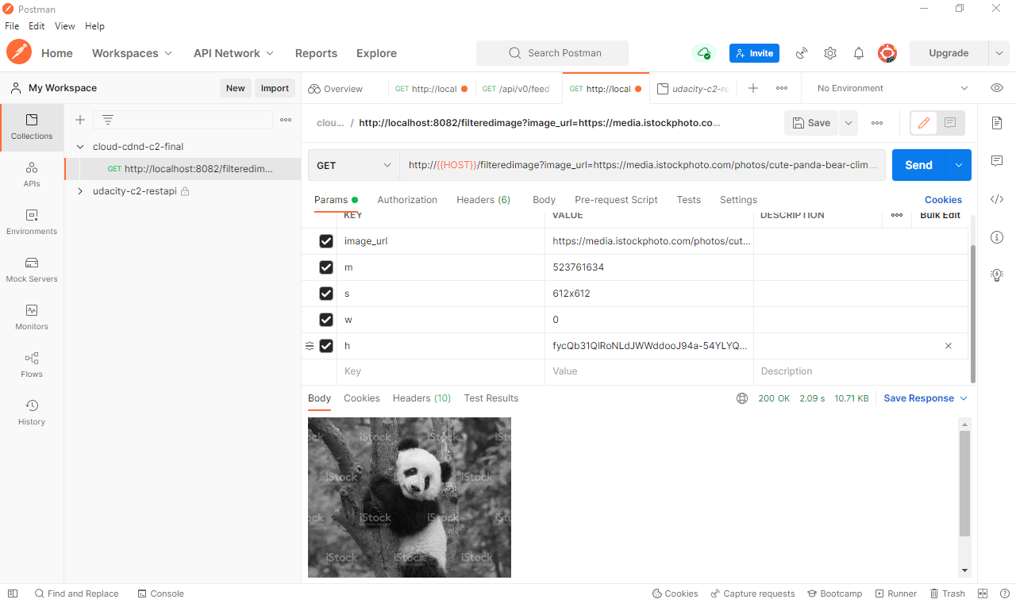

IMAGE URL:

https://media.istockphoto.com/photos/cute-panda-bear-climbing-in-tree-picture-id523761634?k=20&m=523761634&s=612x612&w=0&h=fycQb31QlRoNLdJWWddooJ94a-54YLYQ3ggTLPkhvmk=